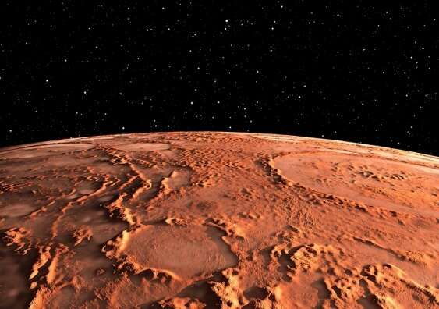
Plutonium-Powered Robot with Its Own Tiny Helicopter on Route to Mars after Practice Landing Using NVIDIA GPU-Powered Simulations

NASA just launched Perseverance, a six-wheeled robot, on a seven-month trek to Mars. The goal is to determine whether there was ever life on Mars (3.8 billion years ago). Perseverance is designed to explore and collect surface samples, but the technology to blast off from Mars and bring samples back to Earth is probably still a decade away. Just getting the rover there and landing it safely will prove a monumental accomplishment.
After a seven-month trip in space, the rover will have just a few minutes to slow from 12k miles per hour to 1.7 miles per hour, in order to land in one piece. The process of safely descending through the Martian atmosphere includes hiding behind a heat shield to keep cool, deploying a parachute to slow further, ignite thrusters to hover, then lower itself in a “sky crane” maneuver. NASA’s target destination on Mars is Jezero Crater, an area full of rock formations.
To prepare for this landing, NASA is relying on NVIDIA GPU-powered physics simulations, using NVIDIA V100 GPUs, NVIDIA IndeX and GPUDirect Storage, part of the Magnum IO stack, to allow researchers to fly through the dataset in real time, volumetrically, and navigate – even as the simulation data continuously updates. GPUDirect Storage speeds up data transfers by bypassing CPUs and sending data directly from storage to the GPU memory. Using the NVIDIA IndeX volumetric visualization SDK, a dynamic visualization can for the first time be generated out of the FUN3D data, each simulation measuring a colossal 150 terabytes. GPUDirect Storage transfers data directly from storage to the GPU memory, allowing users to visualize the entire dataset in real-time. Visualizing 150TB of data.
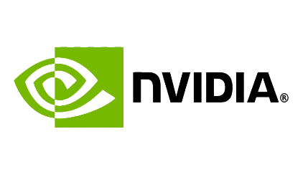
NASA is using WekaIO to feed file data to four Nvidia GPUs for Mars lander descent simulations. This involved 150TB of data and took a one week run with more than 27,000 Nvidia GPUs to produce the simulation dataset. This volumetric data contains about 1 billion data points, each with seven attributes. The simulation can be played in real-time with help from WekaIO Matrix. The system stores the data set files on NVME SSDs, with data fed in parallel at 160GB/sec to four GPUs via Nvidia’s GPU Direct, thus bypassing their host server CPU and DRAM. Without GPU Direct the bandwidth drops to just over 30GB/sec.
Simulations to accomplish landing the rover on Mars rely on three NVIDIA technologies – NVIDIA V100 GPUs, NVIDIA IndeX, & GPUDirect Storage, part Magnum IO –to fly through the dataset in real time, volumetrically, & navigate as data continuously updates.

Features of Perseverance, Mars rover include: 1) a tiny helicopter which may become the first human-made vehicle to take flight on another world; 2) pieces of NASA’s future space suits to test their durability on Mars; 3) microphones to record the sounds of the landing sequence;
4) high-resolution cameras to see what it is like to land on Mars from the rover’s point of view;
5) a drilling system to collect samples, package them, and leave them for later retrieval;
6) instruments to search for signs of ancient microbes that may be lurking in the rocks and dirt on Mars; 7) a hazard map of Jezero Crater, using images taken from spacecraft in orbit around Mars; and 8) a nearly 11-pound package of radioactive plutonium, or plutonium-238. As the plutonium decays, it generates heat, which is then converted into electricity to power the rover.

G2M Research Webinar, Tues, August 25 at 9am
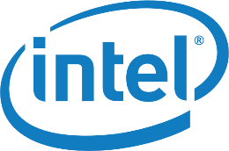
Advanced SSDs - PCle Gen4,
New Form Factors, and Smart SSDs

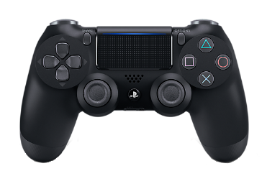
Do We Need U.3, and Who Really Benefits From It?

Ever since NVMe was introduced as a new interface for solid-state drives (SSDs) in January 2013, there has been a “food fight” between supporters of the NVMe 2.5 inch SSD interface (U.2 or SFF-8639) and the SAS/SATA interface for 2.5 inch SSD interface (SFF-8482). The problem is made worse in a sense because the SAS/SATA interface also support hard disk drives (HDDs), while no one has built a hard drive with a U.2 interface to date.
The “disconnect” between these two standards poses a variety of problems:
- It forces server vendors to have SAS/SATA only servers, NVMe U.2-only servers, or to support multiple SKUs, each with a different mix of drives for a given server form factor. That means that a server vendor could potentially have to support 3 SKUs for a 2U, 16-drive server (all-SAS/SATA; all-U.2; and half SAS/SATA, half U.2), or up to 4 SKUs for a 4U, 48-drive server (all-SAS/SATA; all-U.2; and 16xSAS/SATA, 32xU.2; and 21xSAS/SATA, 16xU.2).
- It forces end-users to decide a priori what they will need in their servers for the next 2-3 years: HDDs (high capacity but slow); NVMe SSDs (really fast); or SAS/SATA SSDs (not as fast as NVMe SSDs, but generally cheaper on a per-TB basis). And if you guess wrong (which is likely), you potentially impact system capacity and/or performance for the next three years that you own the server.
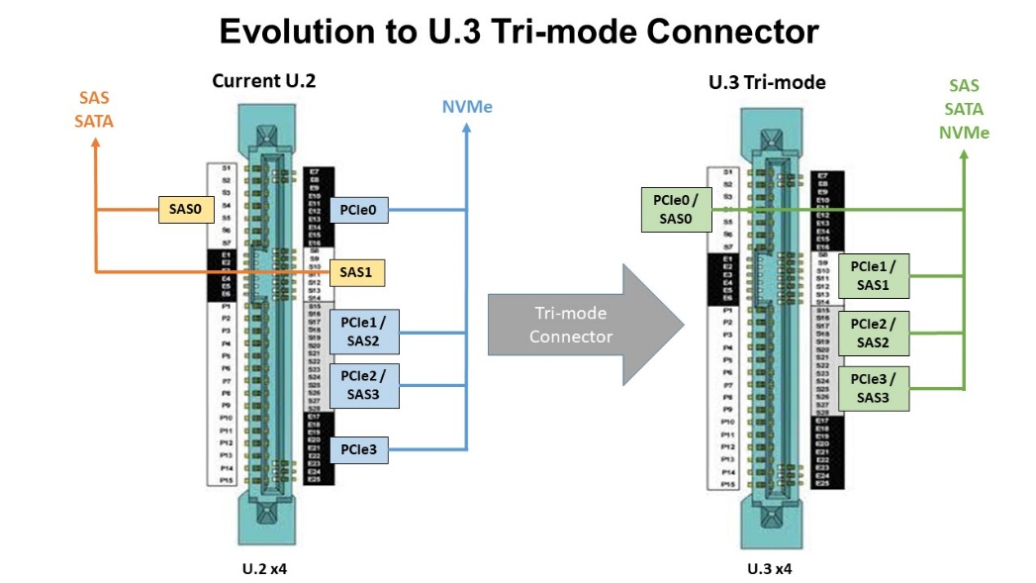
In a sense, U.2 is/was like the PlayStation 4 – you can run the newest stuff on it (NVMe SSDs for U.2, games for PS4), but not the older technologies (SAS/SATA SSDs for U.2, PS1-PS3 games for the PS4). This is why the Storage Networking Industry Association (SNIA) developed the U.3 specification, which is also known as SFF-TA-1001. It provides an interface that supports both SAS/SATA and NVMe U.2 drives in a single connector.
The U.3 specification has potential benefits for many market participants. For the companies such as Broadcom that make the tri-mode interface chips, there is an opportunity to add a new chip to their portfolio, and likely one that is more expensive than the U.2 or SAS/SATA interface chips that it replaces. For server vendors, there is an opportunity to simplify their lineup of SKUs and at the same time provide customers more granular choices as to what media they utilize (NVMe SSDs, SAS/SATA SSDs, and/or HDDs). Similarly, U.3 is potentially attractive to companies that design and build storage arrays for much the same reasons.
For end-users, particularly enterprise datacenter customers, the value is a little less obvious. While having the ability to change the mix of drives and/or add new drives of any flavor to existing servers sounds good, it is something that most large enterprise datacenter operators do not do today. Rather, most deploy a rack of servers in a predetermined configuration, and do not touch the server racks again until they are decommissioned. In fact, many datacenter operators design their deployments so that they can have individual components “fail in place” and not be replaced. For datacenter operators following this approach, U.3 only provides more flexibility in the initial configuration of the server.
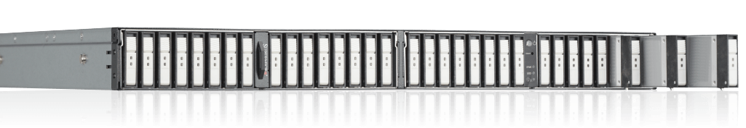
But the real question is whether 2-1/2 inch SSDs, and by extension the U.3 specification, are simply transitional technologies in the deployment of flash storage media. In laptop computers and increasingly in desktop systems, 2-1/2 inch SSDs have been supplanted by the NVMe-based M.2 form factor. But the biggest disruptor in flash form factors is the Enterprise Datacenter Small Form Factor (EDSFF) flash specification, which was designed specifically to maximize the density of flash devices in 1U and larger servers. For 1U servers, EDSFF provides a huge advantage in device count, storage density, and capacity over 2-1/2 inch SSDs, with the ability to support up to 32 devices in a single 1U server. This increase in density and devices should be attractive to datacenter operators (smaller footprint, lower CapEx and OpEx), server vendors, and storage array vendors.
The final question that will determine the long-term success of U.3 is “what happens when NVMe SSDs reach price parity ($/TB) with SAS/SATA SSD?” When this happens, the only use case for SAS/SATA SSDs is as replacements for failed SAS/SATA SSDs or HDDs. Also, the ability to put HDDs and SSDs in the same cabinet is not likely by itself to keep U.3 viable, since hard drives are being relegated to cold storage use cases, which do not require SSDs to be collocated with them. This may be a 2-3-year transition, but customers and technology companies should keep it in mind as they make their technology bets in the SSD market.
Upcoming 2020 Enterprise Storage Events - All Virtual
SNIA SDC, September 22-23
Microsoft Ignite, September 22-24
VMworld US, September 29- October 1
NetApp Insight 2020, October 26-29
Flash Memory Summit, November 10-12
SC 20, November 16-19

Join us "In the Hot Seat"
Let’s talk about what is Hot and what is Not
in the World of High Tech, Storage, and Security

Last year in August most of us were at FMS, networking about the latest and greatest storage ideas. With COVID, everything is postponed, cancelled, or virtual. And, that is great in some respects - saving on travel time and costs, avoiding crowds, and attending zoom meetings in shorts. One of the best things about FMS for G2M last year is we launched our “In the Hot Seat” interviews on the floor of the convention. Yes, there were problems – background noise, equipment failure, skeptical interviewees. It was also a lot of fun! And, the interviews were free, interviewees received a copy of the recording, and we learned a lot about everything going on in the industry. The plan this year included better equipment, strategies for scheduling around the louder events, and streaming the interviews.
The convention floors will be empty (and virtual occupied) so we won’t be on the floor interviewing people this year BUT we could do zoom interviews to highlight things going on in the industry. Sound interesting? Keep in mind, these are not infomercials. But, they could be “industry shorts” to get the word out about events, technology development, challenges, major personnel changes, shifts in direction, and focuses on your area of expertise and interest. We are planning to record a couple of these each week in September.
G2M Research Webinars for the Rest of 2020
As our industry continues to be virtual, webinars can be a good way to stay up to date and get your message out. G2M has several webinars scheduled for this year on hot topics in our industry. Interested in attending our webinars? Register by clicking on the dates of interest. Interested in Sponsoring a webinar? Contact G2M for a prospectus.
Our July webinar “AI, Self-Driving Cars, and Advanced Storage” was sponsored by NVIDIA, Weka, and b-plus. View the recording and/or download a PDF of the slides here.
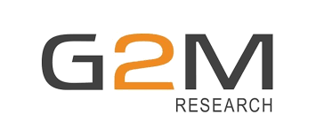

Aug 25: Advanced SSDs- PCIe Gen4, New Form Factors, and Smart SSDs
Sept 15: Edge Computing/Storage – Get (& Keep) Your Data Off Of My Cloud
Oct 20: AI and Storage Use Cases in Healthcare
Nov 17: NVMe-oF™ - Using Telemetry to Improve Network Latency
Check back for additional 2020 company-specific, conference, and other webinars (to be posted soon).
Let us know if there are any endpoint security and/or enterprise storage topics you would like to see covered this year or next.
Our first quarter 2021 webinar schedule will be released soon.

Aug 25: Advanced SSDs- PCIe Gen4, New Form Factors, and Smart SSDs
Sept 15: Edge Computing/Storage – Get (and Keep) Your Data Off Of My Cloud
Oct 20: AI and Storage Use Cases in Healthcare
Nov 17: NVMe-oF™ - Using Telemetry to Improve Network Latency
Check back for additional 2020 company-specific, conference, and other webinars (to be posted soon).
Let us know if there are any endpoint security and/or enterprise storage topics you would like to see covered this year or next.
Our first quarter 2021 webinar schedule will be released soon.

Survey results from our Webinar, Will Storage Systems and Storage Networks Keep Pace with NVMe-oF™? Sponsored by Lightbits Labs, Samsung, and Western Digital
Has your organization explored and/or deployed NVMe-oF based storage systems and/or software yet?
Widely deployed storage arrays &/or storage software utilizing NVMe-oF: 7%
Deployed for some workloads 7%
We are performing proof of concept evaluations on storage arrays &/or storage software that utilizes NVMe-oF for deployment
in the near future: 40%
We are talking to our storage vendors about NVMe-oF: 20%
We don’t expect to utilize NVMe-oF in the next few years: 25%

Survey results from our Webinar,
Will Storage Systems and Storage Networks Keep Pace with NVMe-oF™?
Sponsored by Lightbits Labs, Samsung, and Western Digital
Has NVMe-oF fundamentally changed the value proposition of storage arrays?

No – the value proposition for storage arrays remains unchanged: 2%
NVMe-oF has made software-based storage solutions more
competitive, but storage arrays are still critical to datacenters: 56%
NVMe-oF has leveled the playing field between storage arrays and
software-based storage solutions: 26%
Storage arrays are today only useful for a limited number of use cases: 2%
Storage arrays are essentially obsolete: 4%
No opinion: 11%

